

**Mission 10:**

**Remix**

**Student Workbook**



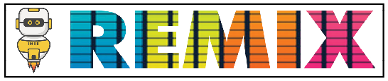

**Make a timely program!**

This assignment will let you be creative and come up with your own program for the   
CodeX to run.

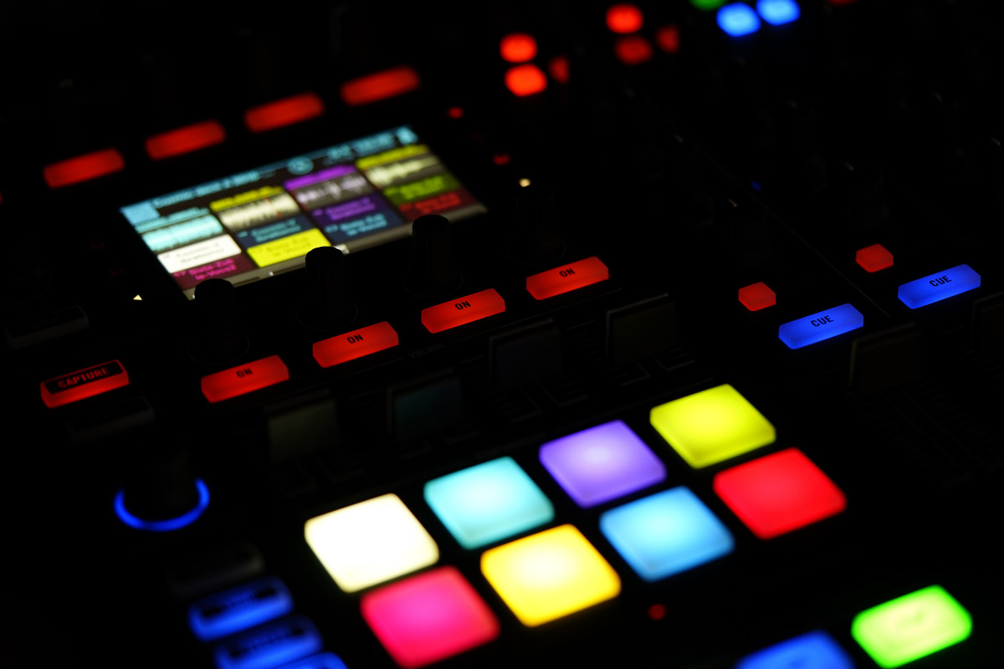

Go to the Mission 10 Remix Log and fill out the Pre-Remix preparation.





**Time for a project remix**

A remix can be:

* A new program created by adding new code to a program you already created
* You can combine parts of two or more programs in a remix
* Use a similar idea in a different way

**Creating a remix will let you:**

* Master the skills and concepts practiced in the mission
* Be creative
* Remember code from earlier programs and missions
* Work with your peers
* Design an original program and write the code all on your own

**Step #1: Review the mission**

* Review your programs from Mission 3 through 10
  + What do the programs do?
  + What skills were used or concepts learned?

**DO THIS:**

* Open your project from Mission 10 -   
   Reaction Tester
* Review what the program does
* Review the programming concepts and   
   skills you learned
* Fill out the information in the remix log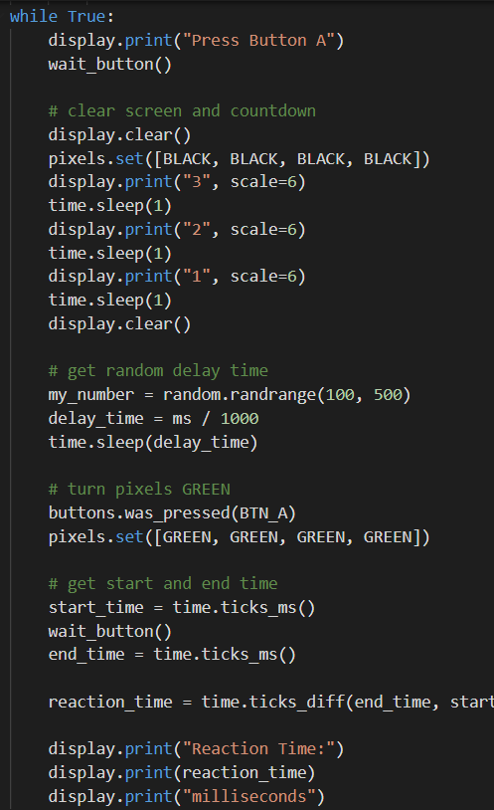

**Step #2: Brainstorm ideas**

* Read through remix suggestions.
  + Eight ideas are on the next pages. You can use any of these ideas or come up with your own.
  + You can combine any parts of the suggestions into your own mild, medium, spicy or extra spicy remix.
* Use your creativity to come up with your own idea for a project.
* Decide with your partner what project you will do.



**Mild Remix #1A**

The code inside the loop is very long. Create a function for the countdown code.

[Video of Remix #1A](https://youtu.be/yeUSTO-bWmM)



**Mild Remix #1B**

Create a function that will give an introduction and wait to start the game (use the wait() function).

[Video of Remix #1B](https://youtu.be/I9SsXe10CDo)



**Medium Remix #2A**

Create a list of colors, and select a random color for the display screen. Use the screen as the indicator instead of pixels.

[Video of Remix #2A](https://youtu.be/R4ZEfl3TJsM)



**Medium Remix #2B**

Create a list of images, and select a random image for the display screen. Use the screen as the indicator instead of pixels.

[Video of Remix #2B](https://youtu.be/hHgQp0p_ECE)



**Spicy Remix #3A**

Make the reaction tester into a game. Use the average time of your reactions as the deciding point. If your time is better than average, add a point. As an option, also subtract a point for slower times.

[Video of Remix #3A](https://youtu.be/6wqwGjLqTKQ)



**Spicy Remix #3B**

Use two images: one for Button A and one for Button B. Select a random button and see if the player presses the correct button. If so, add a point to the score.

[Video of Remix #3B](https://youtu.be/C_0AhbD1XLs)



**Extra Spicy Remix #4A**

Add to Spicy 3A. Choose a way to win or lose the game. Here are two possibilities:   
#1 - Run the test 20 times. If the player scores at least 15 points, they win.   
#2 - Player wins if they get 5 points before getting -5 points, or loses if they get -5 points first.

[Video of Remix #4A](https://youtu.be/JlTG036XmJQ) / [Video of Remix #4AA](https://youtu.be/kD-eaS4i5wM)



**Extra Spicy Remix #4B**

Use the L, R and U buttons to determine which indicator to use. For example, L for pixels, R for images and U for colors. As an extra challenge, use D for a random selection.

[Video of Remix #4B](https://youtu.be/NOJ6ieM_IpQ) / [Video of Remix #4BB](https://youtu.be/d9fo00Fn1x4)

**Step #2: Brainstorm ideas**

**DO THIS:**

* Decide with your partner what project you will do
* Fill out the information in the Mission 10 Remix Log for **Step #2**

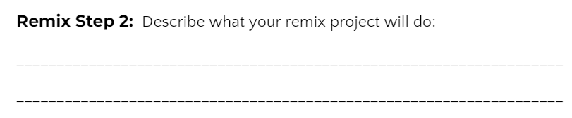

**Step #3: Make a plan**

Now that you have an idea for your remix, you need a plan.

* What variables will you need? What will you use them for?
* What functions will you create for the program?
* Do you need a list? If so, what information will it store?
* What buttons will you program, and what will each button do?

**DO THIS:**

* Fill out the information in the Mission 10 Remix Log for **Step #3**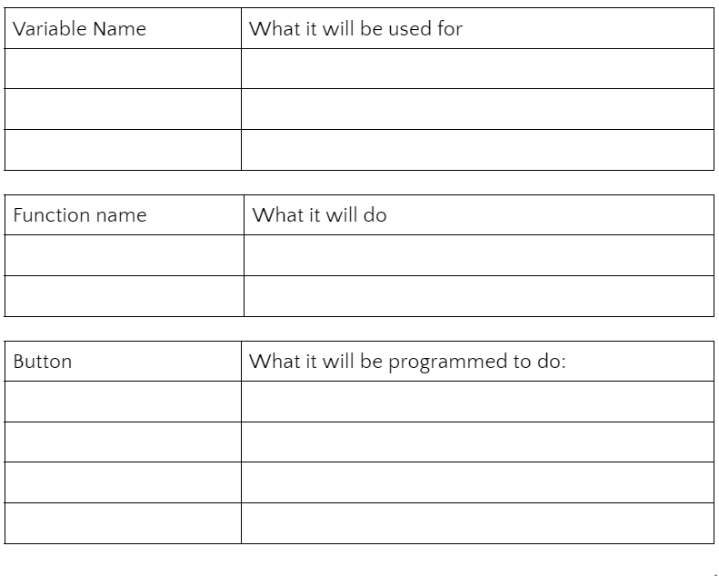

**Step #4: Code your project**

* **IMPORTANT:** In CodeSpace, go to the sandbox: 
* You can leave any program open, including **Reaction Time**, and use it as a guide



**DO THIS:**

* Start with a new file and give it a descriptive   
   name (**Remix10**)
* Import your modules
* Create your lists
* Define your variables
* Write your code, testing frequently

**Reminders!**

* Don’t try to write all the code at one time
* Think about the steps –
  + Just get one thing to work, and then move on
  + Step by step!
* Mistakes happen, so find them early
* Type just a few lines of code and then run the program
* If there is an error, fix it before continuing
* Use the debugger and your other programs for help

**Step #5: Documentation**

You should always make your code readable and easy to follow.

**DO THIS:**

* + - * Add blank lines where needed to divide sections of code
      * Add a comment at the top with your name and the name of the program
      * Add a few more comments to sections of your code that explain what they do

**Step #5: Get feedback**

Getting feedback and reflecting on your code can help you make the program even better.

**DO THIS:**

* Show your code to another student
* Have him/her fill out the feedback form on your   
  Mission 10 Remix Log
* Get feedback from someone else (or yourself)
* Have him/her fill out the feedback form on your   
  Mission 10 Remix Log

**Modify your code to make your project even better**

**Congratulations!**

Now you have your own remix!   
Great job! Share your project with   
your friends.

By completing this remix you have:

* learned more about programming
* used skills and concepts from the missions
* been thinking!
* and problem solving
* and much more!
* 

**DO THIS:**

* Run projects from other   
   students
* Complete the Mission 10 Remix Log
* Don’t forget to clear your CodeX by   
   running your **Clear** program